

How to Register for Patient Services
Before you can use your GP practice's online services, you need to:
- Collect your registration letter from your GP practice.
- Register online to create your Patient Services account.
- Activate your account by verifying your email address and linking it to your GP practice.

Register Your Account
- Go to www.patient-services.co.uk.
- Click Register.
- When asked if you have a registration letter, select Yes.
- Enter the Practice ID from your registration letter.
- Enter your Patient ID and Registration Token from the letter.

Create Your Login Details
Choose the following:
- Username: At least 3 characters. This will be your login name.
- Password: At least 8 characters and include at least three of these:
  - An uppercase letter (A–Z)
  - A lowercase letter (a–z)
  - A number (0–9)
  - A symbol (e.g. !, @, #, $)
- Confirm Password: Re-enter your password.

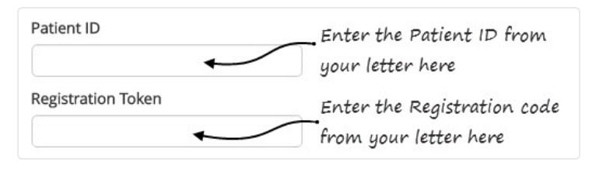

Enter Your Personal Details
Fill in:
- First name (must match your GP records)
- Last name (must match your GP records)
- Email address (should match the one your GP practice has on record)
- Date of birth

Complete Your Registration
- Read the Terms & Conditions and Privacy Policy.
- Tick the box to accept them.
- Click Register.

Verify Your Email
- A confirmation message will appear.
- Open your email inbox.
- Find the Patient Services verification email.
- Click the verification link in the email.

You're Ready!
Once you've verified your email, your Patient Services account is active. You can now log in and use the online services your GP practice provides.

Forgot Your Username or Password?

Forgot Your Username?
If you can't remember your username:
- On the Log In screen, click forgotten username.
- Enter the email address registered with your GP practice.
- Click Recover username.
- If the same email address is used for more than one patient (for example, a child or someone you care for), you'll also need to enter:
  - First name
  - Last name
  - Date of birth
- Click Recover username again.
- Your username will be sent to your email address.

Forgot Your Password?
If you can't remember your password:
- On the Log In screen, click forgotten password.
- Enter your username and click Reset password.
- Check your email and click the password reset link.
- Enter a new password:
  - It must include at least:
    - One uppercase letter
    - One lowercase letter
    - One number
- Re-enter your new password to confirm it.
- Click Reset password.
- When you see the confirmation message, click Login and sign in with your new password.

Change Your Email Address

To update the email address linked to your Patient Services account:
- Log in to Patient Services.
- Select My Account.
- Click Change Email Address.
- Enter:
  - Your new email address
  - Your new email address again to confirm
  - Your current Patient Services password
- Click Update.
- A message will tell you to verify your new email address.
- Open your email inbox and click the verification link in the email from Patient Services.
- Once you've clicked the link, your new email address will be confirmed and updated.

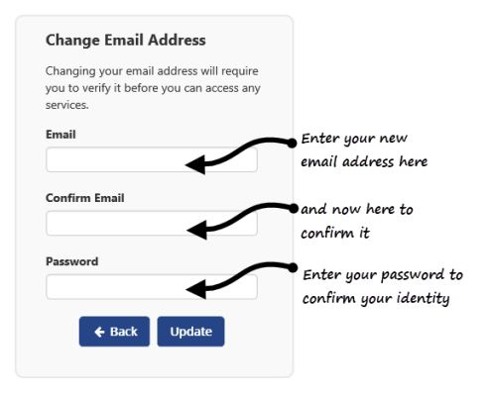

Order a Repeat Prescription

To request your repeat medication through Patient Services:
- Log in to www.patient-services.co.uk.
- Select My Prescriptions.
- Under Available Repeat Prescriptions, tick the medication(s) you want to order.
- Click Request.
- Check your prescription request.
- If your GP practice allows it, you can add a message (up to 1,000 characters). Please note that messages may be read by non-clinical staff.
- Click Confirm to send your request to your GP practice.
- When you see the confirmation message, click Sign Out.
If you cannot order the medication you need, please contact your GP practice for assistance.

Request Other Medication

You can use this option to request medication that is not on your repeat prescription or if your repeat prescription has expired.
Please note: This service is only available if your GP practice has enabled it.
- Log in to Patient Services.
- Select My Prescriptions.
- Tick I'd like to request an expired repeat prescription or another medication.
- Enter the details of the medication you need.
- Click Request.
- Check your request and click Confirm to send it to your GP practice

Book an Appointment

- Log in to Patient Services.
- Select My Appointments to view your existing appointments.
- Click + Add New Appointment.
- Choose your search preferences to find a suitable appointment.
- Select Book next to the appointment you want.
- Check the appointment details.
  - If available, you can add a reason for your appointment.
  - If booking a Travel Clinic appointment, select the country you are travelling to.
- Click Confirm to book your appointment.
- Your appointment confirmation will be displayed.
- You can choose to:
  - Save to Calendar
  - Print your appointment details
If no appointments are available, please contact your GP practice.

Need Help?

Patient Services provides online video tutorials to help you:
- Register for an account
- Order medication
- Book appointments
- You can find these in the Help section of the Patient Services website or visit:
- http://help.visionhealth.co.uk/Patient_Services_-_Patient_Help_Centre/v1.7/Content/Home.htm

